

**Project Report**

**Application Engineering and Development**

**Shruti Mehta NUID:**001252739

MS Information Systems (Fall 2016) [mehta.shru@husky.neu.edu](mailto:Mehta.shru@husky.neu.edu)

**Business Model**

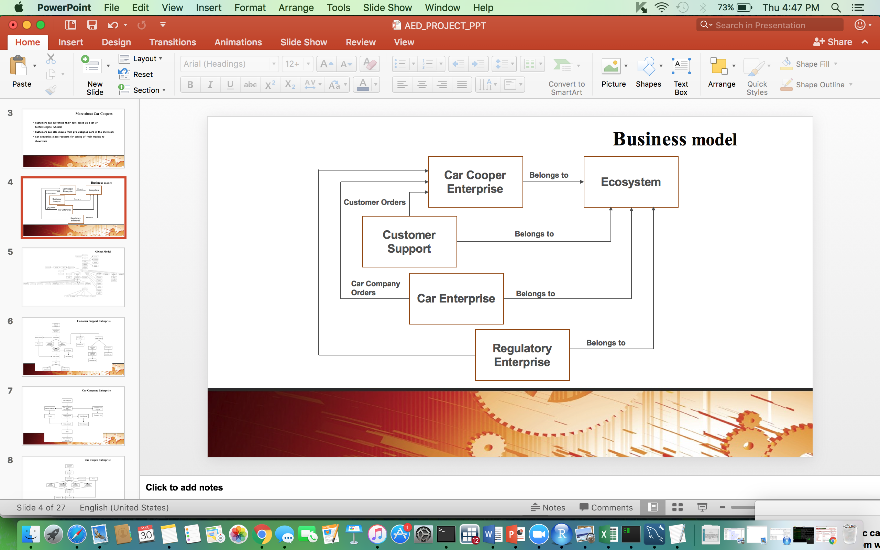

**Object Model**



**Flow Diagram**

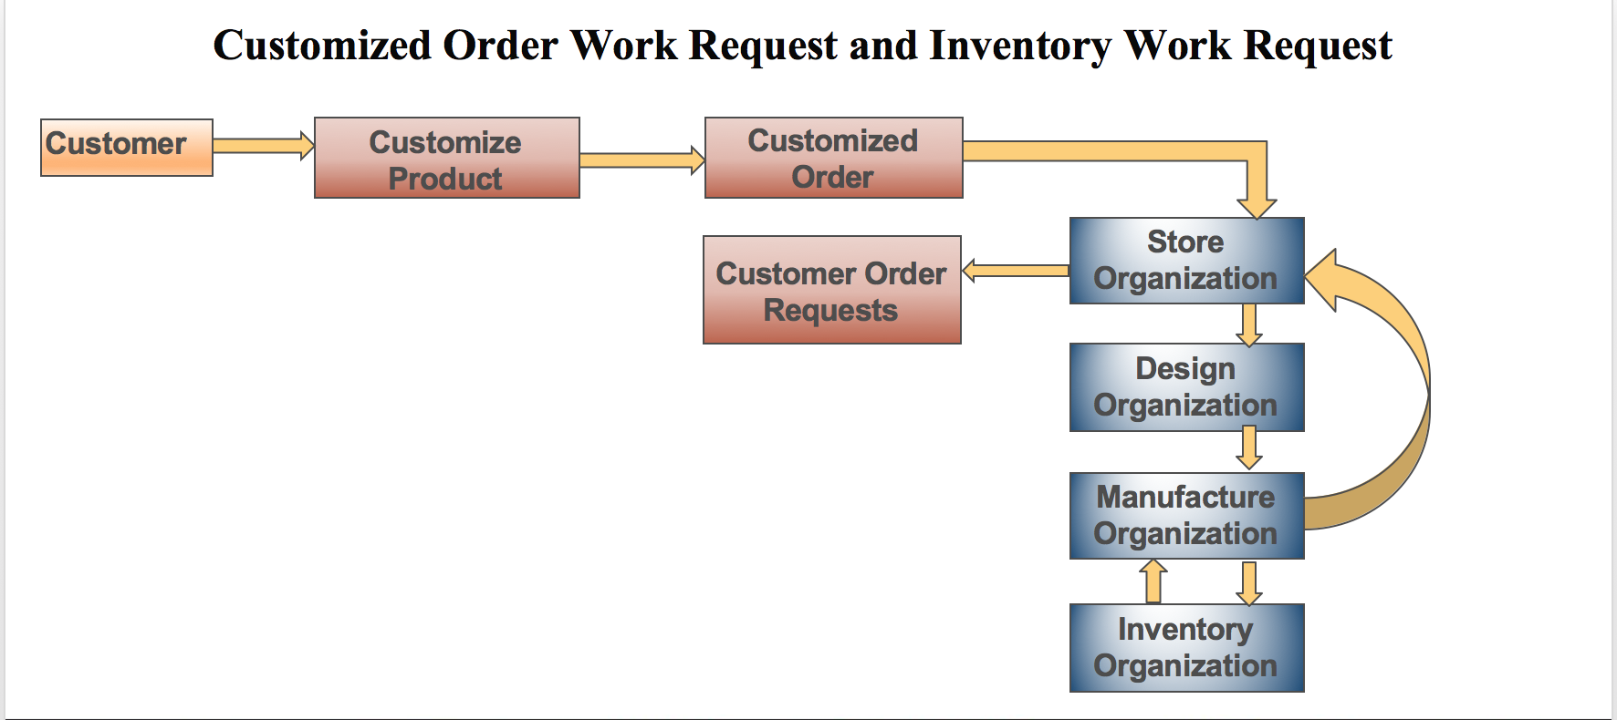

**Login Screen**

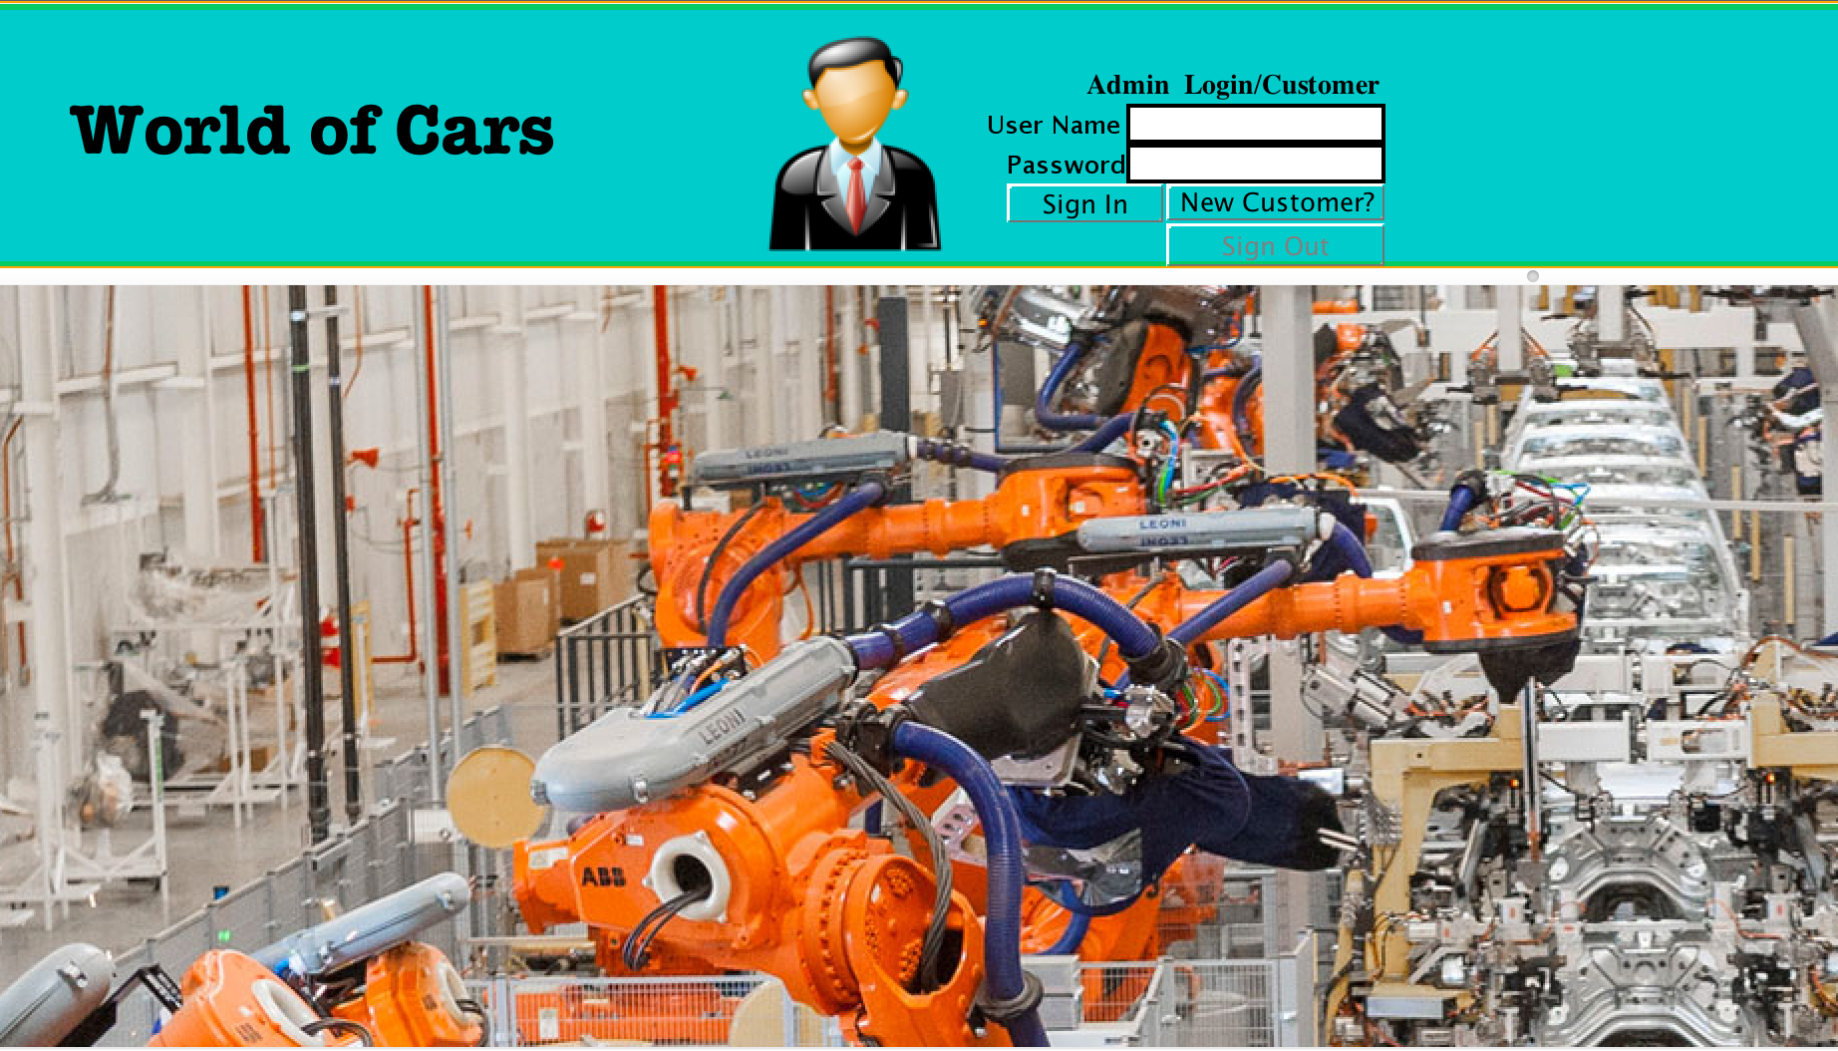

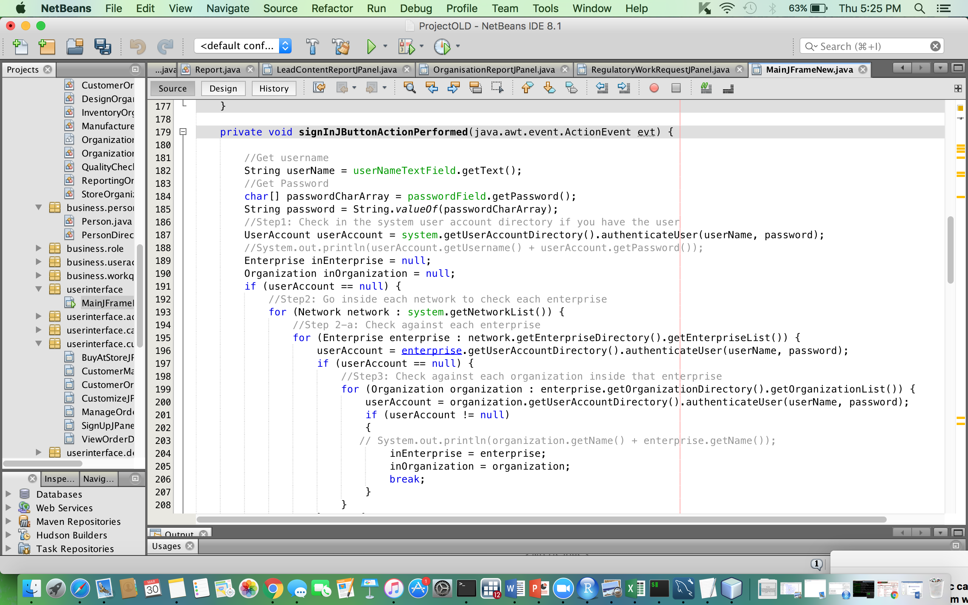

**Customer’s Orders Screen**

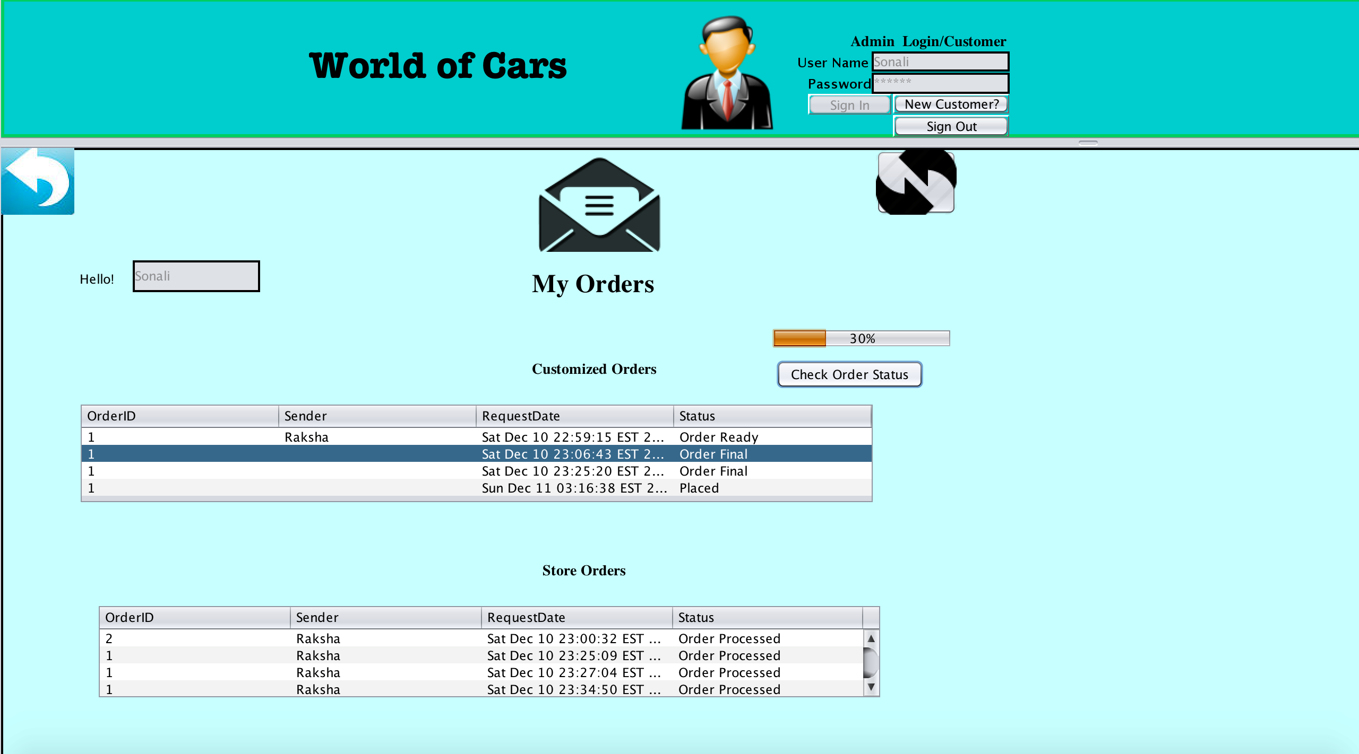

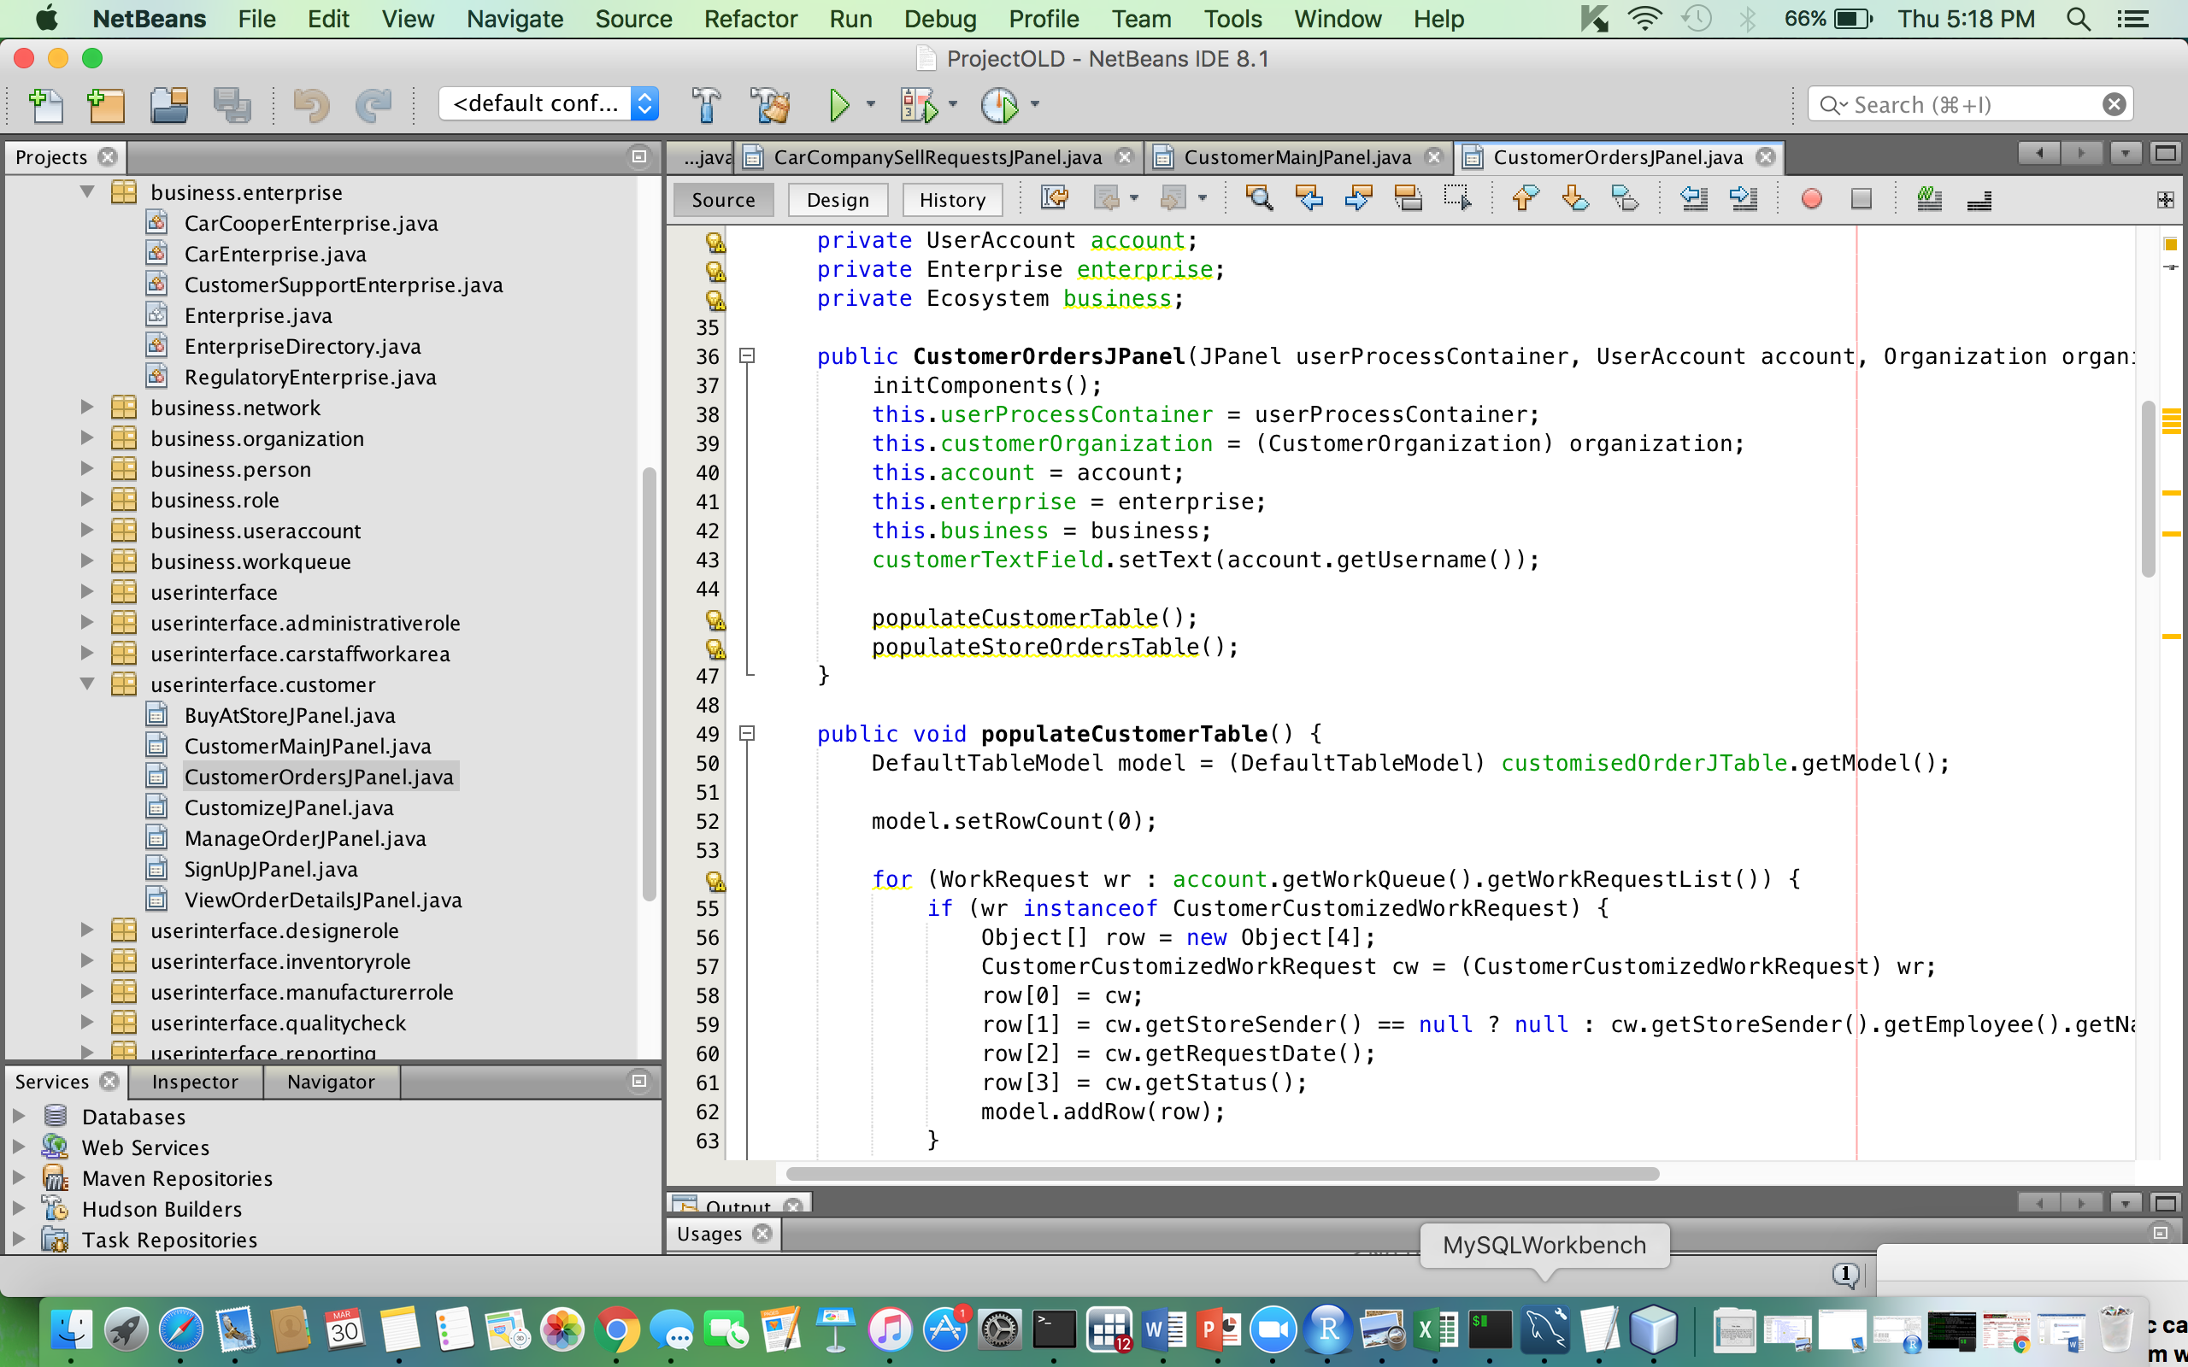

**Work requests Screen**

